Assignment:- 2
Karnaugh Maps (K-maps)
- A Karnaugh map is a graphical method for simplifying Boolean algebra expressions.
- It organizes truth-table values into a grid so adjacent cells differ by only one variable (Gray code ordering).
- Goal: minimize logic (fewer gates) by grouping 1’s (for SOP) or 0’s (for POS) into powers of two.

Types of K-maps-

1. 2 variable

2. 3 variable

3.4 variable

3. Rules / Steps for Using K-maps
- Draw the map
  - Choose 2, 3, or 4 variable grid.
  - Label rows/columns in Gray code order so only one bit changes between neighbors.
- Fill in the map
  - For Sum-of-Products (SOP): place 1’s where the function outputs 1.
  - For Product-of-Sums (POS): place 0’s where the function outputs 0.
- Group adjacent cells
  - Groups must be rectangles with sizes = powers of two: 1, 2, 4, 8…
  - Valid shapes: 1×1, 1×2, 2×1, 2×2, 4×1, etc.
  - Wrap-around edges are adjacent (top–bottom and left–right touch).
- Make the largest group possible always while grouping
  - Each group should cover the maximum number of 1’s (or 0’s) to eliminate the most variables.
- Simplify
  - For each group, write the product (for SOP) of variables that do not change within that group.
  - Combine all group terms with OR (for SOP) or AND (for POS).
- Check for coverage
  - Ensure every 1 (or 0) is covered at least once.
  - Essential groups (covering unique 1’s) must be included.
- Don’t care condition
- In this condition we do not care about the output for the corresponding cell and mark it with an ‘X’ sign.
- We can include this X in our grouping as per need

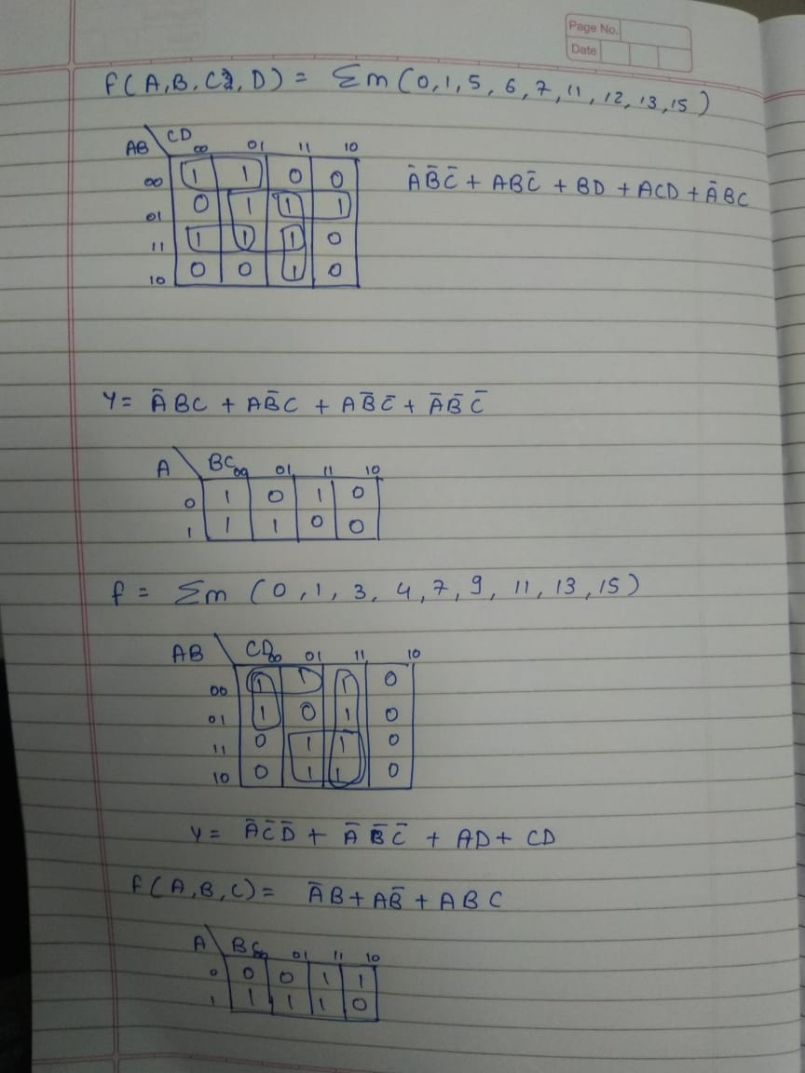

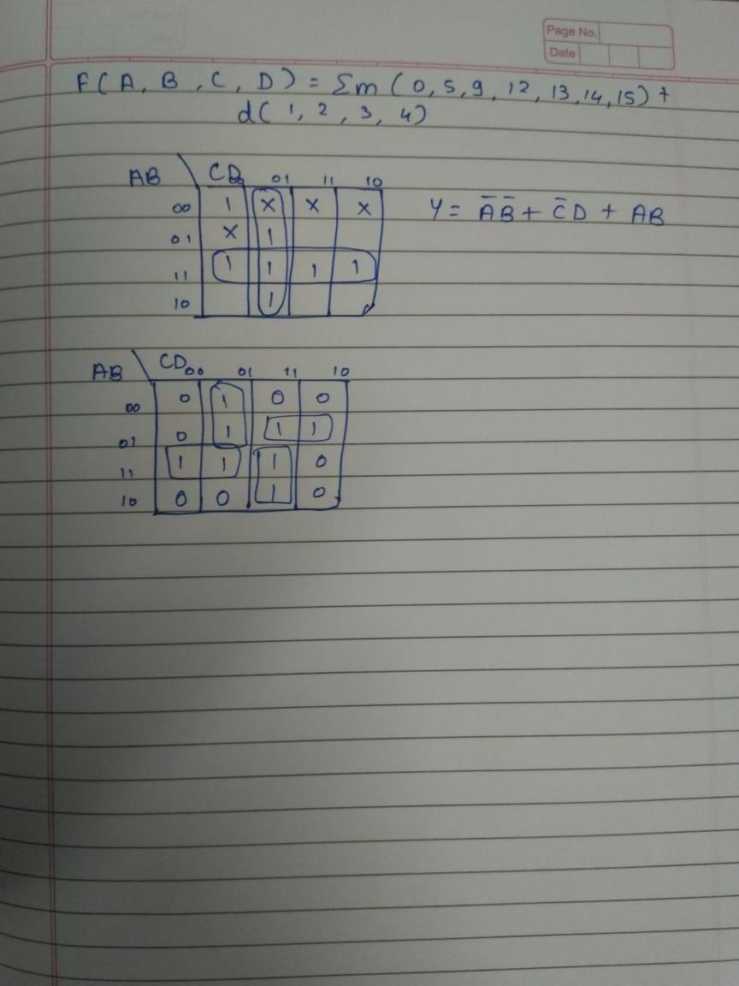

Quine–McCluskey Method (Tabular Method)
The Quine–McCluskey method is a step-by-step, tabular way to simplify Boolean expressions. It is especially useful when the number of variables is too large for a Karnaugh Map.

Why It Is Needed
- Digital circuits use Boolean logic.
- Simplifying expressions reduces the number of logic gates.
- This lowers cost, size, and delay of the circuit.

Key Terms
- Minterm: An AND term where the function is 1 for a specific input combination.
- Prime Implicant: A group of minterms combined together that cannot be reduced further.
- Essential Prime Implicant: A prime implicant that covers at least one minterm not covered by any other.

Steps of the Method
- List the minterms where the output is 1.
- Group minterms by the number of 1s in their binary form.
- Combine adjacent groups that differ by exactly one bit → replace the differing bit with a dash (–).
- Repeat combining until no further merging is possible.
  - Terms that cannot be combined further = Prime Implicants.
- Make a Prime Implicant Chart: rows = prime implicants, columns = minterms.
- Find Essential Prime Implicants: look for columns with only one “X”.
- Cover remaining minterms by selecting the fewest extra prime implicants.
- The final set gives the minimal Sum of Products (SOP) expression.

Example (Outline)
For
F(A,B,C,D) = Σm(0,1,2,5,6,7,8,9,10,14)
- Step 1: Convert minterms to binary and group them.
- Step 2–3: Combine until no more reduction is possible.
- Step 4: Identify prime implicants.
- Step 5–7: Select essentials and cover remaining terms.
- Step 8: Write the simplified Boolean function.
Advantages
- Works for any number of variables.
- Always gives the minimum expression.
Disadvantages
- Becomes lengthy by hand if variables > 5–6.
- Better handled by computer programs for large cases.

Applications
- Digital circuit design.
- Logic minimization in compilers and CAD tools.
- Teaching and learning Boolean simplification.

